FIFA 2026 PROJECT ANALYSIS
This is a data set of FIFA 2026 .this data set track individual player performance. this data doesn’t needed cleaning it was already a clean data , this data analyzed the following situation or scenario
- Scoring efficiency
- Tactical benchmark
- Overall match rating
- Competition breakdown

Steps or procedure
this data was in csv file so I directly loaded into Power Bi ,the data was a big single table around 13,397 and 21 columns . and also there are also null or blank values in some columns while calculating the result may be error so I made fact table and dimension tables for easy and understandable calculation

Goals per 90
then created the custom column called goals per 90 .why this column raw total goals can be misleading and also players do not play the same time as other players
(example if a player 30 + min and other player only 15+ )
FACT TABLE
then created the fact table and named it fact player match it contains all the columns in the data set
DIMENSION TABLE
After creating the fact table then I created dimension table
- Dim player
1)player name (removed duplicates )
2)nationality
3)position
4)age
5)market value

- Dim Club
1)club (removed duplicate )

- Dim competition
1)competition
2)season
RELATIONSHIP
So I have created one fact table and 3 dim table and then I have connected tables
Dim player (player name )

Fact player (player name )

Dim club(club)

Fact player (club)

Dim competition (competition )

Fact player (competition)

I connected the fact and dimension table to many to one ,single .so the relationship step is done here and then I have created the measure from the guide line and some measures from outside the guide line

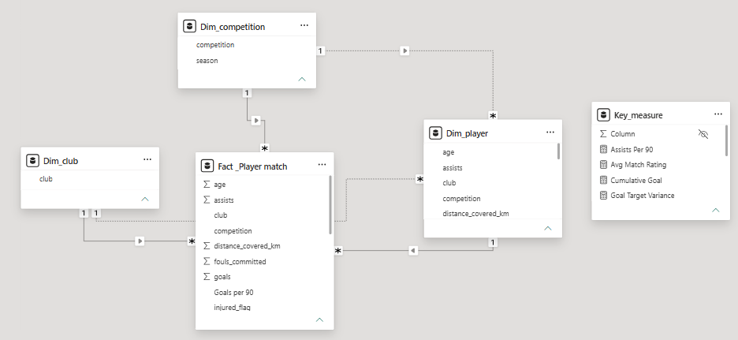

MEASURES
These are the measures I have used in this data set

- Assists Per 90 = DIVIDE([Total Assists], [Total Minutes], 0) * 90
- Avg Match Rating = AVERAGE('Fact _Player match'[match_rating])
- Cumulative Goal = CALCULATE([Total goal],FILTER(ALLSELECTED('Fact _Player match'),'Fact _Player match'[match_id] <= MAX('Fact _Player match'[match_id])))
- Goal Target Variance = VAR TargetGoalsPer90 = 0.40RETURN [Goals Per 90] - TargetGoalsPer90
- Goals Per 90 = DIVIDE([Total goal],[Total Minutes], 0) * 90
- High Work Rate Rating = CALCULATE(AVERAGE('Fact _Player match'[match_rating]),'Fact _Player match'[distance_covered_km]>=10.0)
- Performance Status = SWITCH(TRUE() ,[Goals Per 90]>=0.5,"World Class",[Goals Per 90]>=0.2,"Regular Contributer","Bench Option")
- Player Goal Rank = IF(HASONEVALUE(Dim_player[player_name]),RANKX(ALL(Dim_player[player_name]),[Total goal],,DESC,Dense))
- Total Assists = SUM('Fact _Player match'[assists])
- Total goal = SUM('Fact _Player match'[goals])
- Total Minutes = SUM('Fact _Player match'[minutes_played])
These are the measures I have used in this project next I have created an hierarchy

HIERARCHY
I have created hierarchy and named it position hierarchy in the hierarchy I have add the position and player name
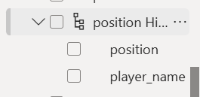

TABLES AND MEASURES
In this data I have used a separate table for measure to easily identify the measures and other tables
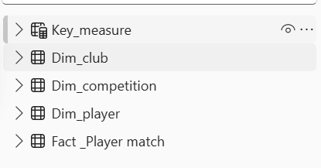

LAYOUT
After all this I have created my own design or layout for this project in the theme of FIFA after arranging all slicers and other KPI cards ,charts and other filter buttons here is the visual of the report creation

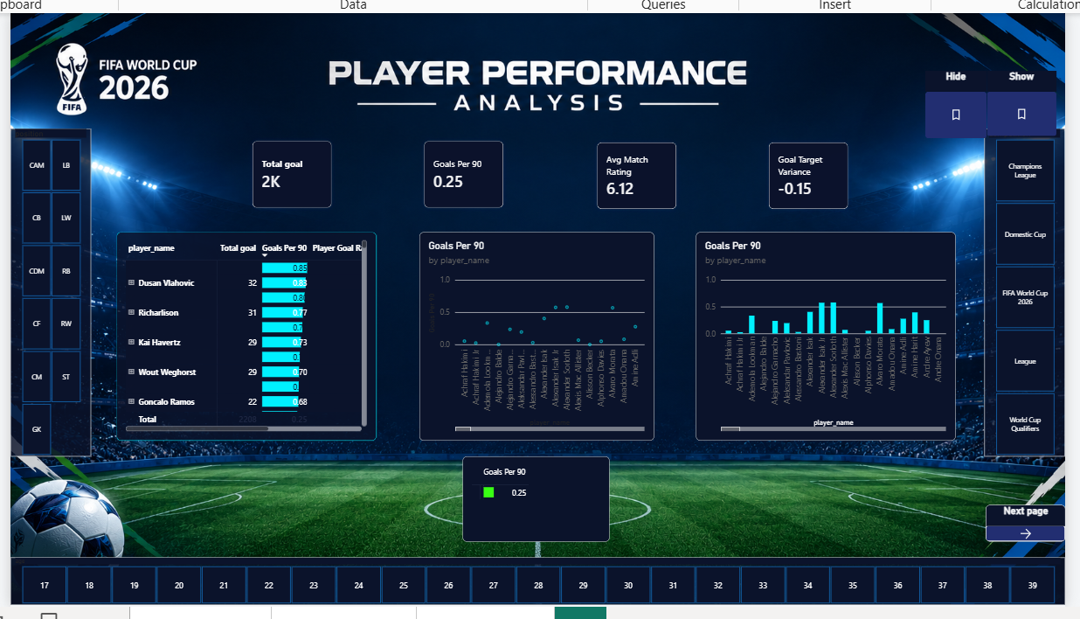

this is the end of my report of FIFA 2026 PLAYER PERFORMANCE ANALYSIS .

Abisinan cp
07/10/2026
Wednesday

